F1 Car Computer Vision Model

- Description

This project addresses a computer vision task. The goal of this project, train a model that can accurately identify an F1 car's team from an image.
Domain Computer Vision (Image-based Classification).

We are classifying the images of a F1 car into four constructor/manufacturer teams: Scuderia Ferrari HP, McLaren Racing Limited, Mercedes-AMG PETRONAS Formula One Team, and Oracle Red Bull Racing using two different machine learning models and compare those results.
Overview of the upcoming result, the highest validation accuracy (85.35%) was attained by a hybrid model that used an SVM as a classifier and a CNN as a feature extractor.

- Dataset

Source the dataset used is the "F1 Car Classification" dataset from Roboflow Universe.

Data Size the dataset contains two splits, loaded from CSV files (_classes.csv):
- Training: 6657 validated image filenames.
- Validation: 628 validated image filenames

Preprocessing & Augmentation, all images had been resized to 224x224 pixels to fit the base model's input dimensions.
- Pixel values normalized to a [0, 1] range by dividing by 255.
- The training data generator applied random augmentations which is aimed to improve model generalization:
- Rotation (20 degrees)
- Width/Height Shift (0.2)
- Shear (0.2)
- Zoom (0.2)
- Horizontal Flip
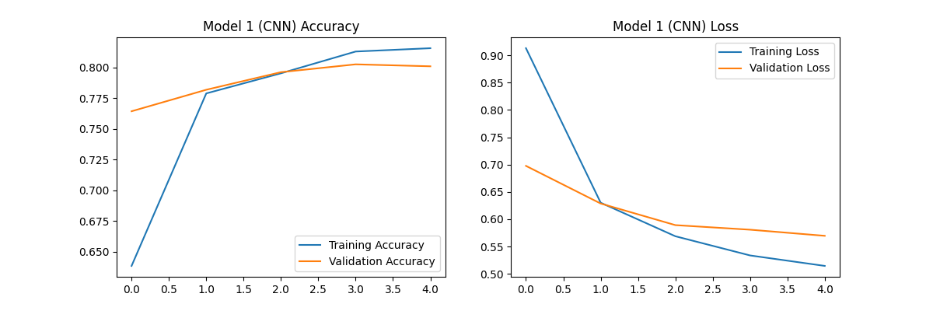
- Methods

Two models were taken for a comparative analysis.

- Model 1: End-to-End Deep Learning (CNN)

The Transfer Learning with MobileNetV2 (a Convolutional Neural Network).
The pre-trained MobileNetV2 base (trained on ImageNet) is loaded with include_top set to=False.
The base model's layers are frozen (base_model.trainable = False) so only the new classifier head would be trained.
A new head was added:
GlobalAveragePooling2D() layer (to flatten features).
Dense(4, activation='softmax') layer (for 4-class classification).
Training the model was mixed with adam optimizer and categorical_crossentropy loss. It was trained for 5 epochs.

- Model 2: Hybrid Model (CNN as Feature Extractor + SVM)

Architecture: MobileNetV2 (as feature extractor) + Support Vector Machine (SVM) (as classifier).
The trained base_model from Model 1 (up to the GlobalAveragePooling2D layer) was used as a feature extractor.

Both the training (6657) and validation (628) datasets were passed through this extractor. This converted each 224x224 image into a 1280-dimension feature vector.
A usual Support Vector Classifier (SVC) from scikit-learn is initialized (kernel='rbf').
The SVM is trained on extracted feature vectors (features_train) and also their corresponding labels (labels_train).

- Steps to Run Code

In environment used to run the code we had a T4 GPU runtime.
Install Dependencies: Run the first code cell to install roboflow, tensorflow, scikit-learn, pandas, and seaborn.
API Key: The notebook uses a hardcoded API key from RoboFlow to download the dataset automatically thought the API we needed to provide a Link to of the Dataset.
Run all cells in the notebook in order from top.
The script will download data, train Model 1, train Model 2, and generate all comparison charts and reports between model 1 and 2.

- Experiments & Results

The performance of both models was evaluated on the 628-image validation set.

Performance Metrics

Model | Type Validation | Accuracy
Model 1 | End-to-End CNN | 80.10%
Model 2 | Hybrid (CNN+SVM) | 85.35%

Accuracy: 80.10%. CNN Accuracy and Loss

Classification Report (Model 1):

Class | precision | recall | f1-score | support
Ferrari | 0.92 | 0.63 | 0.75 | 194
Mclaren | 0.83 | 0.81 | 0.82 | 127
Mercedes | 0.72 | 0.92 | 0.81 | 182
Redbull | 0.79 | 0.89 | 0.83 | 125
accuracy |  |  | 0.80 | 628
macro avg | 0.82 | 0.81 | 0.80 | 628
weighted avg | 0.82 | 0.80 | 0.80 | 628

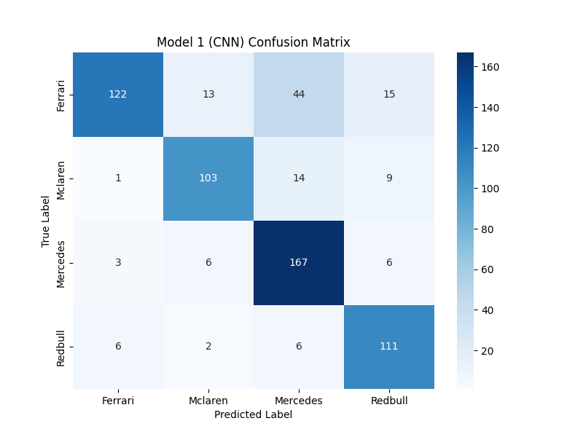

Analysis: The CNN model was weakest on Ferrari, showing a low recall (0.63). This indicates it missed many Ferrari images. It also had a high tendency to misclassify other cars as Mercedes (92% recall but only 72% precision).
Confusion Matrix (Model 1): CNN Confusion Matrix

Loss/Accuracy Curves: The training and validation loss/accuracy curves are generated by the notebook on the runtime.
Confusion Matrix, CNN model showed the most confusion between Ferrari and Mercedes, and also misclassified some Red Bull cars as Mercedes.

F1-Scores (per class):
Ferrari: 0.75
McLaren: 0.82
Mercedes: 0.81
Red Bull: 0.83

Model 2 (SVM) Results

Accuracy: 85.35%.
Classification Report (Model 2):

Analysis: The SVM classifier improved performance across all classes. The F1-score for the Ferrari jumped widely from 0.75 to 0.82. The model was strongest at identifying Red Bull (0.90 F1-score) and showed a better balance of precision and recall overall.

Class | precision | recall | f1-score | support
Ferrari | 0.85 | 0.78 | 0.82 | 194
Mclaren | 0.91 | 0.83 | 0.87 | 127
Mercedes | 0.79 | 0.92 | 0.85 | 182
Redbull | 0.92 | 0.89 | 0.90 | 125
accuracy |  |  | 0.85 | 628
macro avg | 0.87 | 0.86 | 0.86 | 628
weighted avg | 0.86 | 0.85 | 0.85 | 628

Confusion Matrix (Model 2): SVM Confusion Matrix
Confusion Matrix: The SVM model showed significant improvement. Misclassifications were reduced across all classes, especially for Ferrari.

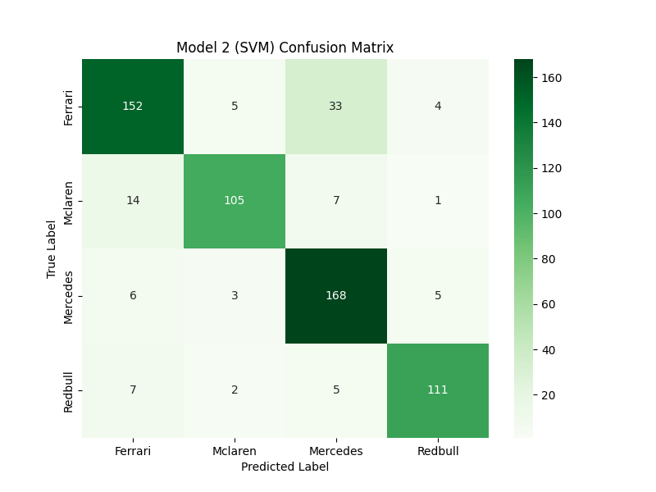
F1-Scores (per class):
Ferrari: 0.82
McLaren: 0.87
Mercedes: 0.85
Red Bull: 0.90
(Note: All comparison charts are generated in the .ipynb notebook output.)

- Conclusion

Two models were successfully used and compared. The hybrid (CNN+SVM) model was the one which outperform the end-to-end CNN model by over 5% in accuracy.

Final Comparison

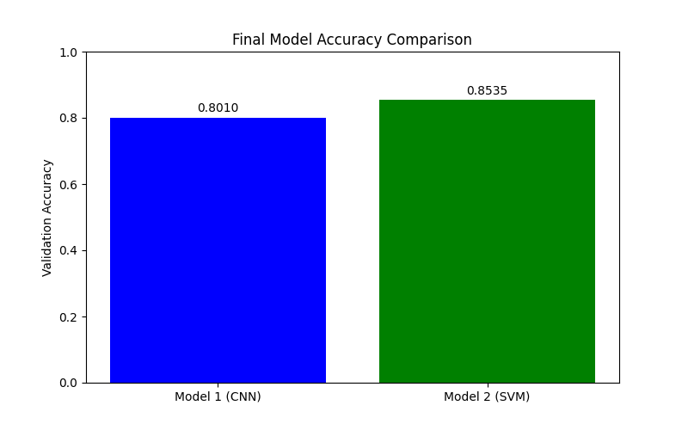
This tells that while MobileNetV2 is an excellent feature extractor, the SVM with an RBF kernel is a more powerful and effective classifier for this specific dataset than the CNN's default Dense layer.
The SVM model is strongest at identifying Red Bull (0.90 F1-Score) and weakest at identifying Ferrari (0.82 F1-Score), though it was still a significant improvement over the CNN's 0.75 F1-Score for Ferrari.

- References

Dataset: F1 Car Classification.->
Roboflow Universe the source of the dataset (https://universe.roboflow.com/f1-car-detection-model/f1-car-classification)
Libraries: TensorFlow/Keras, Scikit-learn, Pandas, Roboflow.

